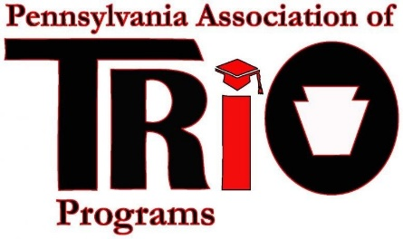
Pennsylvania Association of TRIO Programs
State Meeting (at MEAEOPP) – April 10, 2017
Fair Share Committee Report

Committee Members:
Dr. Susan E. Powell
Timeline of Recent Activities / Announcements:
January 25, 2017 Participated in Conference call: What is Fair Share, The Basics.
The Resource Development Manual was reviewed.
Relevant Highlights:
Fair Share is COE’s Unrestricted Funds ($3,346,000) and is about half of COE’s Annual Budget.
Each Region has a budget amount: MEAEOPP - $255,803
Two Components to making Fair Share: 1) Institutional Membership 2) Personal contributions
Fair Share Year: July 1 – June 30
The cost of an institution’s membership is an allowable cost.
February 8, 2017 Conference Call with (AEEE and MEAEOPP):
Discussion:
    - COE Updates
    - Fair Share Monthly Report
    - Winter Campaign
    - 10 for 10 goals and progress
March 15, 2017 Conference Call:
    - COE Updates
    - Fair Share Monthly Report
    - Spring Campaign ($300.00 discount ends May 31, 2017)

For the Month of March PA TRIO is at 60% of reaching its annual goal.
If you have not already heard Jesse Baker resigned effective March 31, 2017. Invoices will be sent out during April 10- 14, 2017 reminding institutions about the dues for those that will expire July 1 – December 31, 2017. If your institution membership has an expiration date that falls between those dates please look for the invoice and follow up.
Major Goals:
Increase the number of paid institutional members. Encourage those who are able to make personal contributions
Respectfully Submitted:
Dr. Susan E. Powell

