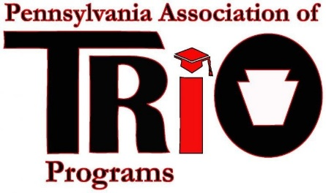
Pennsylvania Association of TRIO Programs
State Meeting (at MEAEOPP) – April 10, 2017
President’s Report

Timeline of Recent Activities / Announcements:
- Conferred with Scholarship, Legislative Affairs, Financial Affairs and Membership committee chairs about major goals and plans for this year.
- Attended MEAEOPP Board of Director’s meeting on November 17-18, 2016 in Charleston, WV.
- Volunteered to chair the Governmental Relations Committee for MEAEOPP.
- Participated in several Fair Share calls with COE.
- Held conference call with Virginia Keithley, Past-President of MEAEOPP to discuss conference agenda and call for proposals.
- Participated in phone meeting on January 4, 2017 with President-Elect and Past-President to discuss conference plans and goals.
- Participated in a Budget Planning Meeting via Wiggio with the PA TRIO Financial Affairs committee to discuss the FY 2017-18 Budget on January 19, 2017.
- Planned and attended PA TRIO winter board Meeting via Wiggio on January 27, 2017.
- Made outreach for and selected two participants for MEAEOPP’s ELI (Emerging Leaders Institute) to represent PA TRIO: Kim Shelton and Joanna Martin.
- Attended COE’s Seminar on Relations with US Department of Education March 19-20, 2017.
- Attended COE’s Policy Seminar March 21, 2017.
- Participated in Policy Seminar advocacy efforts / “Walk on the Hill” by visiting 2 Pennsylvania legislative offices, the D.C. office, and 2 Delaware offices.
- Planned the MEAEOPP conference breakout sessions as the Conference Call for Proposals and Moderator Chair.
- Serve on the ELI faculty and will present “Leadership and YOU” workshop to ELI training.
- Will attend the MEAEOPP Board meeting and Conference April 9-12, 2017.
- Planned and will present “Implementing and Creating a Fact Book for Your Program or Association” with Michele Lagnese at the MEAEOPP Conference 2017.

Board Positions / Vacancies:
- PA TRIO has no vacant Board Positions at this time.
Other News:
- Would like to continue work on the PA TRIO Strategic Plan in the next few months.
- Spoke with Frank DelleCurti about launching a form on the website to continue to sell the PA TRIO T-Shirts for profit.
- COE is encouraging all members to join at least one “Community of Practice.” More information: http://www.coenet.org/communities.shtml

Updates from COE as of 4/7/17:
Upward Bound
Institution/Agencies began hearing last week if their proposal was rejected for various reasons. COE is hosting calls for proposals rejected for exceeding the budget and double spacing. Contact angelica.vialpando@coenet.us if you have received a rejection letter.

The U.S. Department of Education stated last week that their goal is to have the first slate out by late April/early May. The funding band slate could come out as late as early June. Dr. Byrd-Johnson says they will try hard to have the slate out the last week of May but it could slip into June.

Upward Bound Math/Science
Proposals were due on March 22.

Veterans Upward Bound
The U.S. Department of Education stated that the final application should come out in late June/early July.
VUB 17-18 was posted in the Federal Register for comment. Comments are due May 9, 2017.

McNair
The Federal Register notice for McNair was posted on Saturday, February 18 with the application posted on Tuesday, February 28. The due date is April 7. ED has also posted a number of inconsistencies with the RFP and the answers to those issues. This information can be found at https://www2.ed.gov/programs/triomcnair/applicant.html.

Student Support Services
SSS APR for 17-18 was posted in the Federal Register for comment. Comments are due April 10, 2017.

GEAR UP
GEAR UP Partnerships and State Competitions were announced last week. Due dates are April 19, 2017 for partnerships and April 24, 2017 for state grants.

Low-Income Levels
The 2017 Federal TRIO Low-Income Levels were posted on the ED website last week. Information can be found at https://www2.ed.gov/about/offices/list/ope/trio/incomelevels.html.

New Reports Released by ED
ED released Fast Facts Reports on SSS, TS, UB and UBMS which discuss program outcomes. These can be found at https://www2.ed.gov/about/offices/list/ope/trio/index.html#news. Fast Fact Reports on McNair will come out soon. No word on EOC or VUB reports.

Respectfully Submitted:
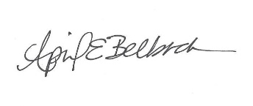
April E. Belback, President, PA TRIO

