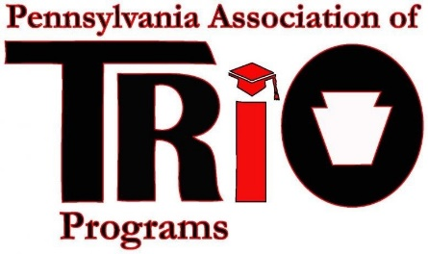
Pennsylvania Association of TRIO Programs
State Meeting (at MEAEOPP) – April 10, 2017
Conference Committee Report

Committee Members:
Kim Shelton & Susan E. Powell

Timeline of Recent Activities / Announcements:

Conference calls: February 16, 2017 & March 28, 2017
Date and Location of Conference: October 17 – 20, 2017, Ramada Inn in Ligonier, PA
Theme for the conference: “Inspiring the Next TRIO Generation to Lead”

Major Goals:
Include a Murder Mystery Comedy show and dinner for $41.00, 2 ½ hour show Wednesday, October 18, 2017 evening show.
Invite inspirational speakers, local government leaders to share in the conference.
Registration and other information will be sent out via email once plans are finalized.

Respectfully Submitted:
Kim Shelton, President Elect
Susan E. Powell- Past President

