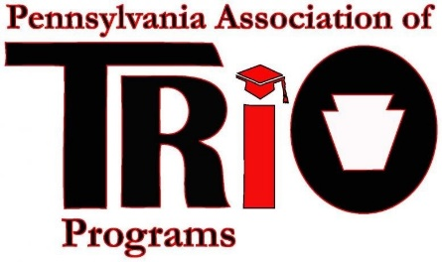
Pennsylvania Association of TRIO Programs
State Meeting (at MEAEOPP) – April 10, 2017
MEAEOPP Report
April E. Belback, President Kim Shelton, President-Elect

The MEAEOPP Board of Directors met on November 17-18 in Charleston, West Virginia. The following agenda items were discussed:
- ELI (Emerging Leaders Institute) Class of 2017
- MEAEOPP Website
- Social Media Presence for MEAEOPP
- TRIO Achievers
- The 2018 Conference will be taking place in Maryland
- Budget
- Fair Share (MEAEOPP is currently at 56%)
- COE Communities of Practice
- Leadership Opportunities
- Policy Seminar
President Leo Conway presented a “Move Your Bus” agenda that included icebreakers and motivational and informative information from author Ron Clark. We were able to discuss constitution, strategic plan, state reports, committee reports and the above agenda.
MEAEOPP 2017 Conference is April 9-12 in Charleston, WV. There will be pre and post-conference opportunities. The theme is TRIO: Own It Now and Inspire the Next Generation.
The MEAEOPP Board of Directors met on Sunday, April 9, 2017 in Charleston, West Virginia. The following agenda items were discussed:
- ELI (Emerging Leaders Institute) Class of 2017 began before the conference with 6 members.
- Current membership – 455
- MEAEOPP has new website: http://meaeopp.org/wordpress/
- MEAEOPP is second in country for regions for Fair Share – thank you for your support. But, PA still needs some growth. $300 discount if you pay by May 31st for next group.
- Budget
- We passed a motion to terminate the College Goal Sunday account as a Fiscal Agent.
- We passed a motion to continue the application for the Paul Spraggins State Initiative Grant for 2017-18 with the intention to utilize it for the ELI program / Alumni outreach.
- Conference 2018 sites – Maryland (April 14-18?)
- President Leo Conway plans to engage Board in a Leadership / Involvement Survey
- Policy Seminar
Respectfully Submitted:
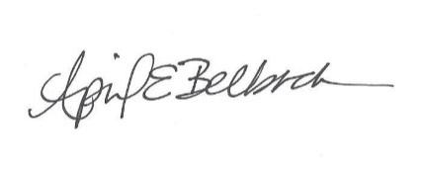April E. Belback, PA TRIO President

