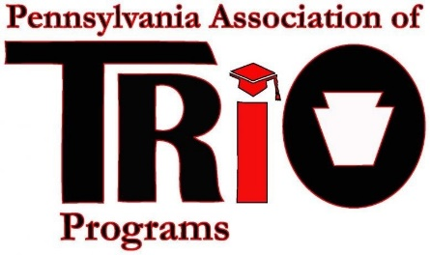
Pennsylvania Association of TRIO Programs
State Meeting (at MEAEOPP) – April 10, 2017
Financial Affairs Committee Report
Committee Members: April Belback (President, DUS – Penn State University Greater Allegheny), Leo Conway (Chairperson, UB - Saint Francis University), Christal Graham-Jones (Development Chair, TS – Penn State University), Connie Kugel (SSS – Seton Hill University), Susan Powell (Past President, UB – Lincoln University), Kim Shelton (President-Elect, SSS – Mansfield University), George Tatone (TS - Penn State University), and Melissa Derhammer (Treasurer, SSS - Kutztown University).

Timeline of Recent Activities / Announcements:
In the first part of January, all committee chairs and officers were contacted via email, given their respective line items from the current budget, and asked to submit a budget for next year. Chairpersons and officers responded and their input was then used to put together the budget for the next fiscal year.
The Financial Affairs Committee held a Wiggio Virtual Meeting on Thursday, January 19th, to outline what had been requested by officers/chairs, discuss budgetary issues, and create a proposed budget for FY 17-18. The Board of Directors approved the budget during its meeting on January 27th, while the general membership will vote on the 2017-2018 budget here at our state meeting during the MEAEOPP conference in Charleston, WV.
Please note the following about the proposed 2017-2018 budget:
- The budget is balanced, as required by the Fiscal Management Manual.
- There is NO proposed increase in either membership dues or conference registration fees.
- The one-day professional development seminar income and expense line items are based on three sites.
- The fundraising income line item is the same as the amount budgeted for FY 16-17.
- Money is put into the budget again to send both the President and the Legislative Affairs Chairperson to the Policy Seminar. The amount for each is increased by $300 because of the increase in costs to attend.
- Travel for the TRIO Achiever remains the same as FY 16-17. Keep in mind that MEAEOPP already provides a plaque to the recipient so that line item has been zeroed out.
- Conference expenses have been decreased a bit from what was budgeted last year, but have been increased when compared to the recent State College expenses. The line items are also based upon the contract with the Ramada Inn in Ligonier.
- An Outstanding Service Award line item has been added at a cost of $60. This recognition had previously been done at the MEAEOPP conference, but it has now been given back to states so that the TRIO professionals may be recognized in front of the “home crowd” at state conferences.
- The number and amount of PA TRIO scholarships have not been changed in the proposed budget, however, the Financial Affairs Committee recommended (and the Board accepted) that the scholarship amount be increased by $250 to $750 per recipient. The additional funds ($2,750) will come from the money market account. Surpluses from previous fiscal years make up the money market account.
- Line items with $0 have either not been used in the past or are being done at no cost via email and/or the internet. Others are being covered by individual programs.

Major Goals:
Creation of FY 17-18 Budget (completed)
Revision of the PA TRIO Fiscal Manual
Alternative Financial Review Methods

Respectfully Submitted:
Leo Conway

Financial Affairs Committee Chairperson

