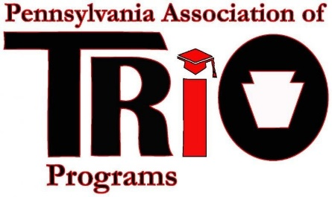 Pennsylvania Association of TRIO Programs

State Meeting at MEAEOPP – April 10, 2017

Legislative Affairs Committee Report

|  |
| --- |
| **Committee Members:**  Erik Austin – SSS, University of Pittsburgh Bradford campus  April Belback – SSS, Penn State Greater Allegheny  Mickey Bellet – Upward Bound and Upward Bound Migrant, Penn State University  Crista Gray – SSS, Gannon University  Stephen Holoviak – Talent Search, Penn State University  Catherine Mulcahey – SSS, Mansfield University of PA |

**Timeline of Recent Activities / Announcements:**

* December – E-mail communication with membership requesting information about those planning on attending Policy Seminar
* January – E-mail communication with those attending to provide information/draft table for appointments; e-mail communication with listserv regarding attendance at Policy as well as inviting letters/cards
* February/early March – Updated the Policy Seminar schedule to reflect the most recent changes in Members, offices, and contact information as well as appointments that were scheduled
* February/early March – Reviewed the links in the Fact Book, updated the information, and identified some web site links that need to be updated; moved the Fact Book to the new Google Site
* Created Resource folders for each office that contained the Fact Book, cards/letters, and a new “Quick Reference” sheet for each office/member for individuals to use prior to visits to familiarize them with the member’s important issues, bio, and other pertinent information

**At Policy (March 21-22, 2017)**

* Nineteen (19) individuals walked the Hill representing 12 different colleges/universities in our state; seven (7) Team Leaders set up advance appointments with congressional offices
* Thank you to Leo, Susan, Michael, and all others who brought alumni to the Hill to speak. Their voices made more of a difference than any of ours ever could. Also, thanks to those who forwarded cards and letters that were included into the folders for the legislators.

**Major Goals:**

* Collaborate with the Conference Planning and Scholarship Committees to arrange for Senator Casey’s office to attend the PA TRIO Scholarship Banquet in Ligonier
* Work on perfecting the new Fact Book/site/QR code

Respectfully Submitted:

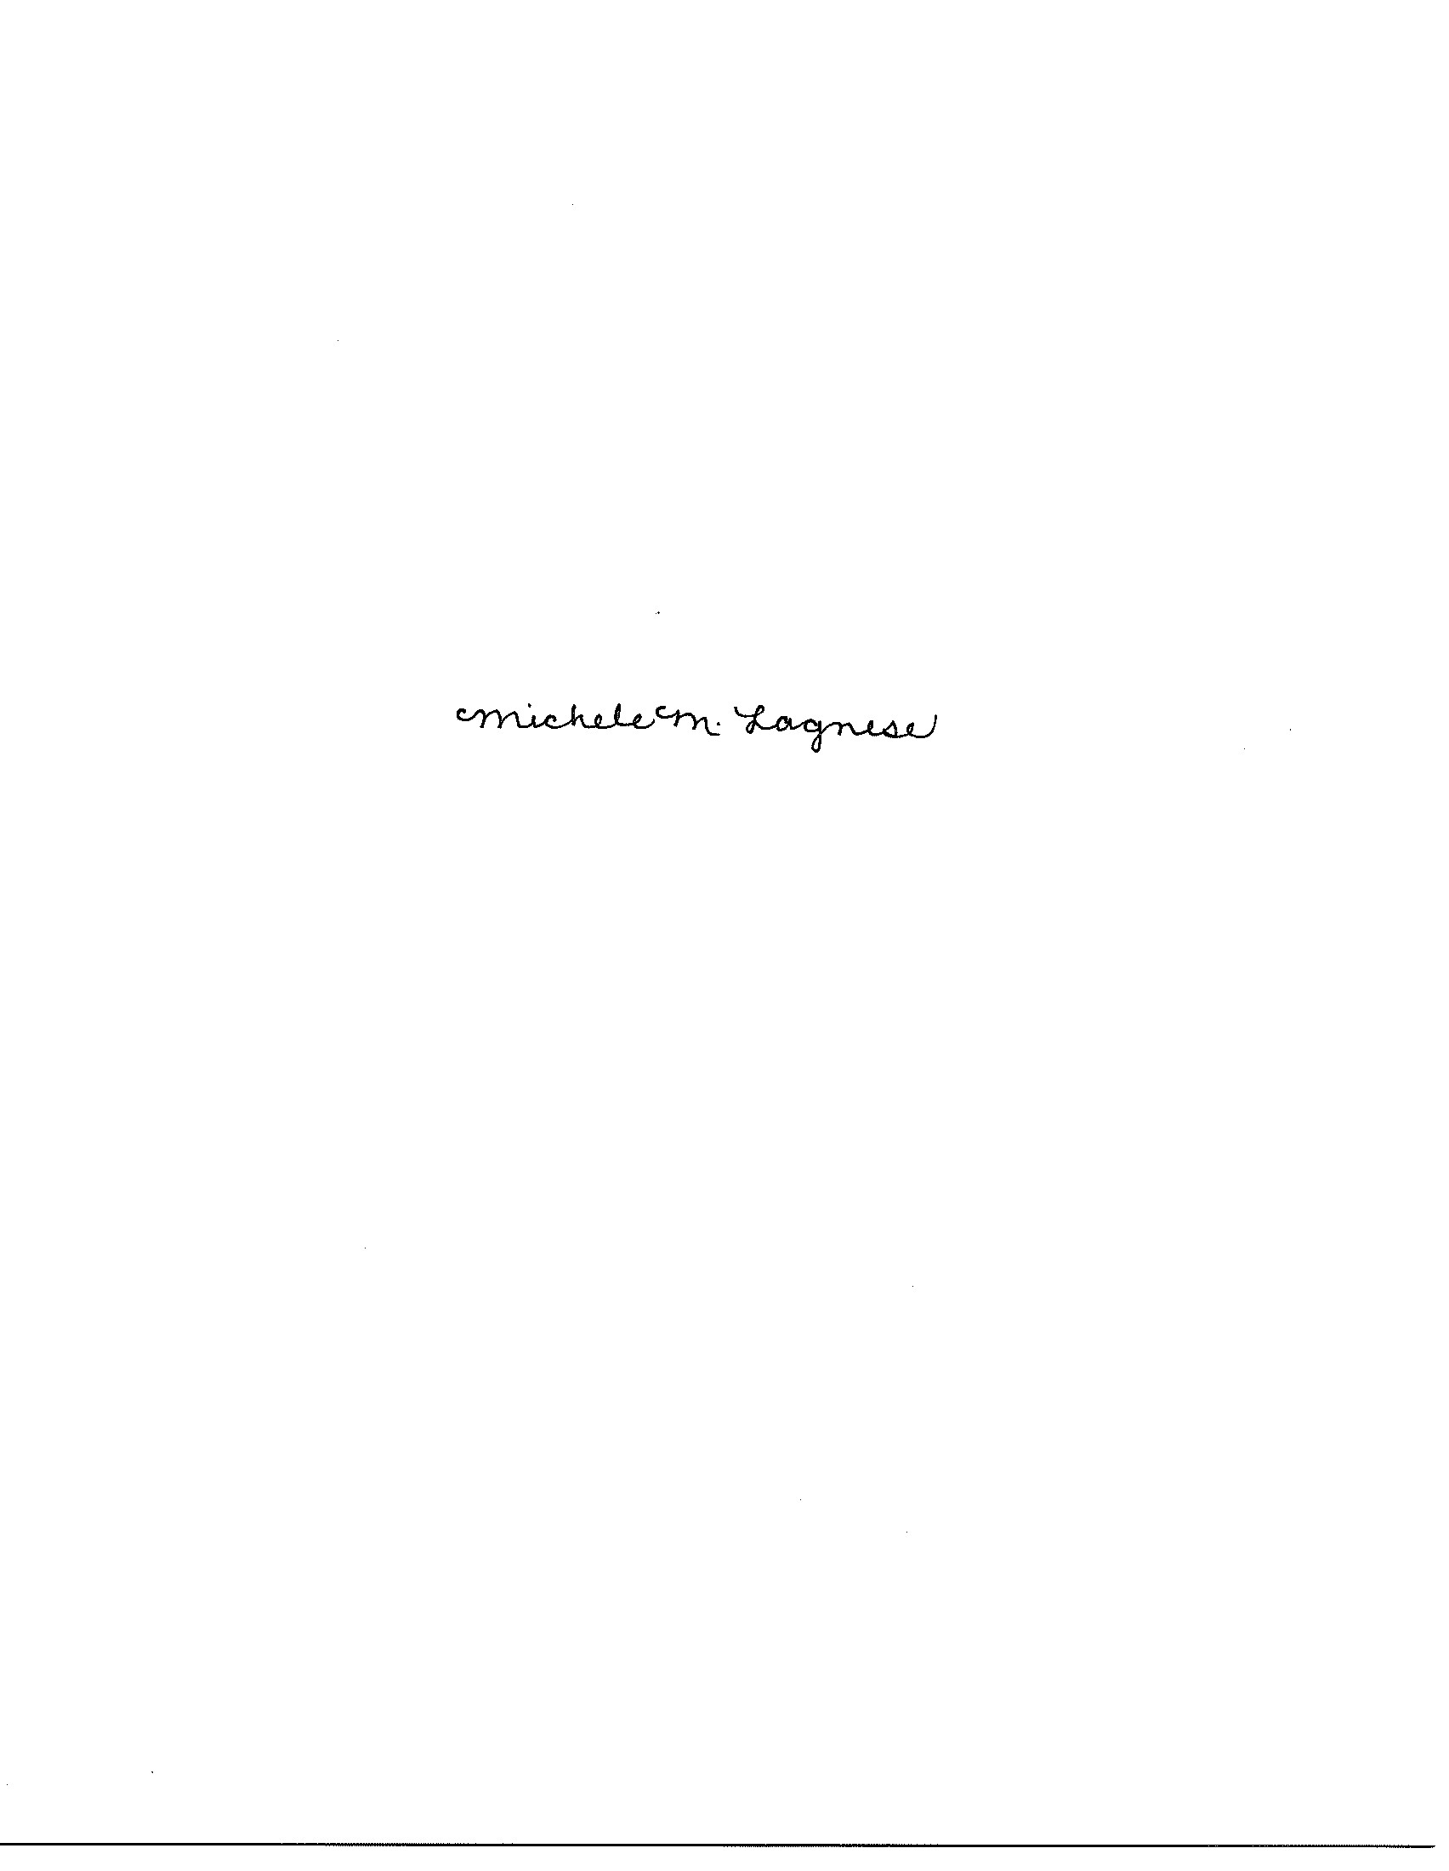

Appendix / Resources (Attachments to include): Draft Policy Seminar Schedule 2017

