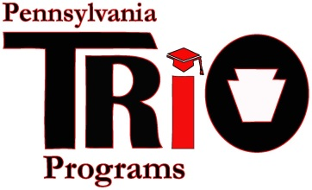

PA TRIO Scholarship

Student Requirement Guidelines

SPECIAL NOTE TO PROJECT DIRECTORS/NOMINATORS: Please use this sheet as a reference for what is asked on the Google nomination form.

The Scholarship Committee requires all nominees to complete two parts of the 2024-2025 PA TRIO Scholarship Application/Nomination process. Below you will find a description of each part and the focal points to address in each one. Each nominee will provide his or her TRIO Director/Nominator with these requirements to make the nomination valid. If these are not included with the nomination form, the nominee will be excluded from further consideration. Please make sure that you address all focal points and requirements listed in the boxes below.

PART #1: ESSAY

How has your participation in a TRIO program helped you to become the person that you are today and will be in the future?

Include the following three focal points and any additional information you would like to share with the Scholarship Committee:
1. Achieving academic goals
2. Personal growth
- Long-term goals or aspirations

*IMPORTANT! Please do NOT name specific TRIO programs in your essay.
For example, write “Being a part of a TRIO program…” instead of “Being a part of the Upward Bound program...”

PART #1: FORMATTING CRITERIA & REQUIREMENTS
- Appropriate grammar use and spelling
- Minimum of 400 words – maximum of 500 words

PART #2: LIST OF ACTIVITIES & AWARDS

Using only the last 5 years as a time frame, list the activities in which you have participated, leadership positions you have held, and awards and honors you have received.
Activities, awards, honors, and leadership positions should be ones that have contributed to your growth as an individual and could be academic, extra-curricular, and/or community in nature.

Please LIST your activities. This part is not an essay.

