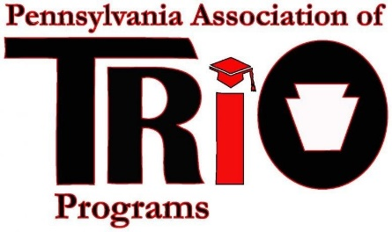
Pennsylvania Association of TRIO Programs
State Meeting (at MEAEOPP) – April 10, 2017
Nominations Committee Report

Committee Members:
Dr. Susan E. Powell

Timeline of Recent Activities / Announcements:
Review the Call for Nomination information and constitution about the responsibilities of the Nomination Committee.

Major Goals:
The Goal of the Nominations Committee will be to swear in a new President-Elect and Treasurer at the 2017 annual conference at the Ramada Inn in Ligonier, PA. More information will follow as we get closer to the conference.

If anyone is interested in serving on this committee please contact me.

Respectfully Submitted:
Dr. Susan E. Powell

Appendix / Resources (Attachments to include):

